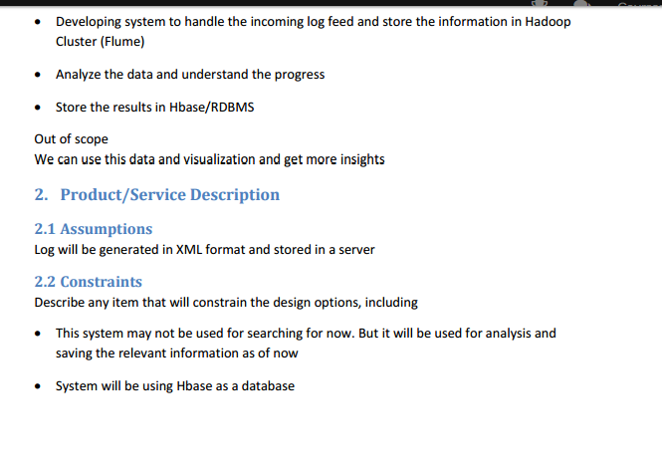

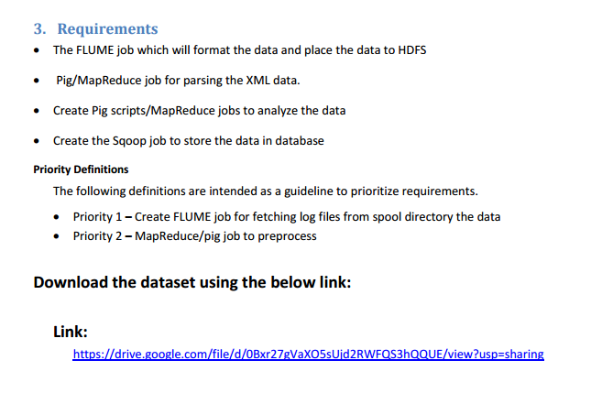

**FILE LOCATION:**

* The file is loacted inside the flume<conf for using loading the fiel into pig y making use of flume.

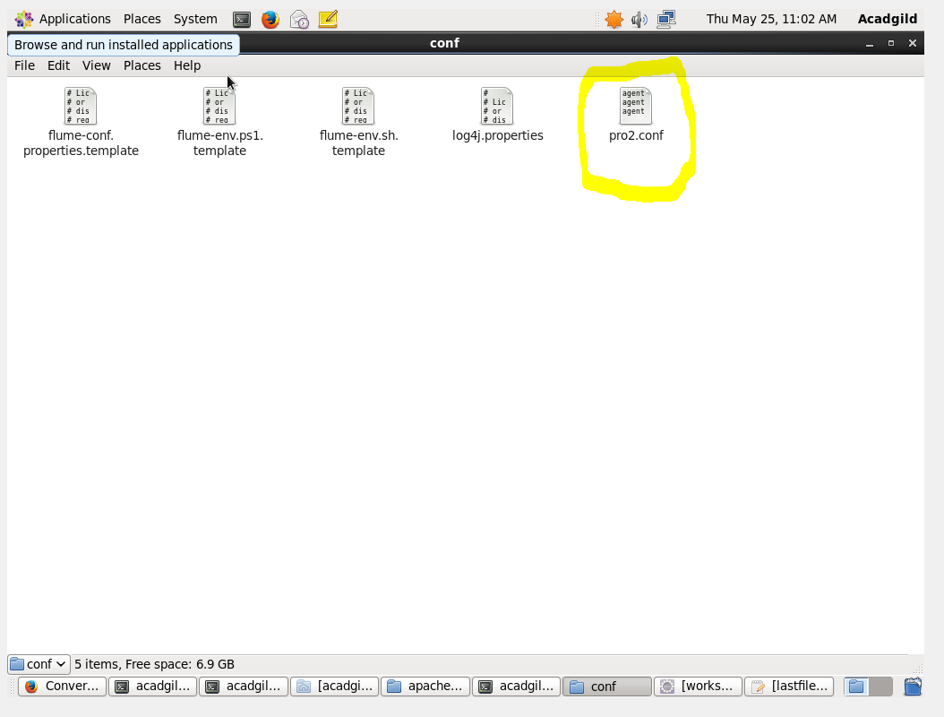

**DATA INGESTION INTO HDFS USING FLUME:**

* Flume - distributed, reliable service.
* Mainly will be used for moving large amounts of log data.
* As well for the purpose of collecting and aggregating.
* The architecture of flume is simple which is based on data flows.
* As well it is highly fault tolerant and many failover and recovery mechanisms.
* Flume will load data into hdfs at a high speed.
* Directory named ***flume_import*** was created.

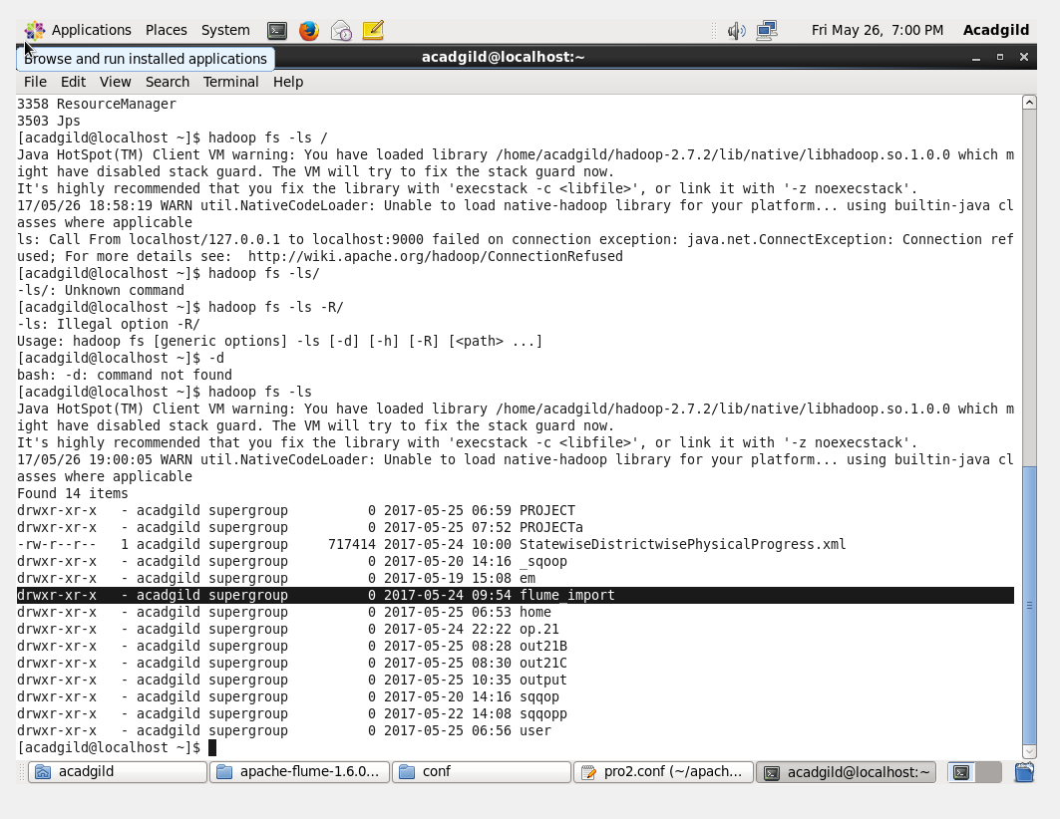

Contents Inside the flume directory:

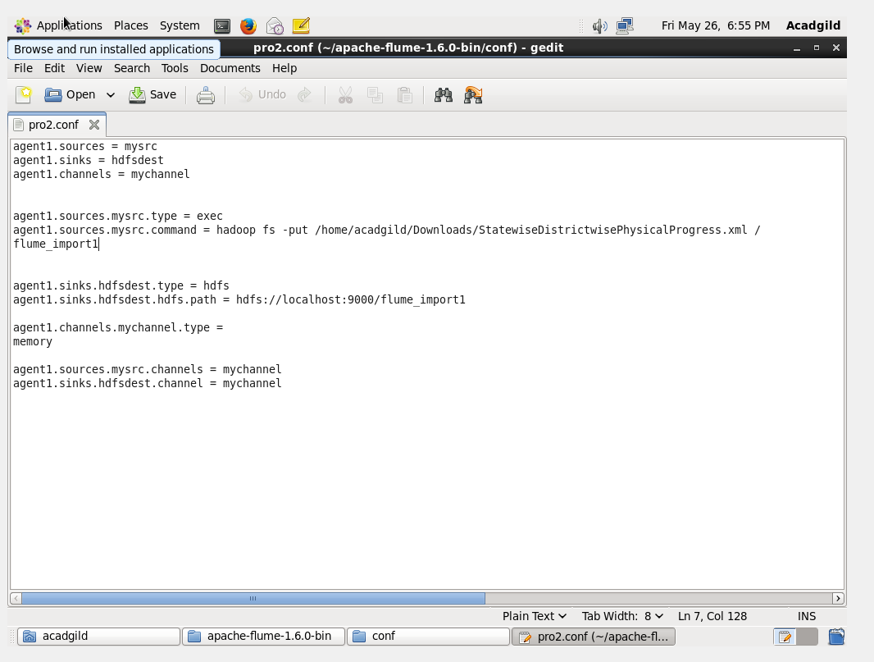

**Flume command to load the dataset( which is in XML format) into the HDFS.**

RUNNING FLUME COMMAND:

* Flume command is made to run to make all the file in the XML format to enter into HDFS(Hadoop Distributed File System).
* And the directory was given where the file is located.

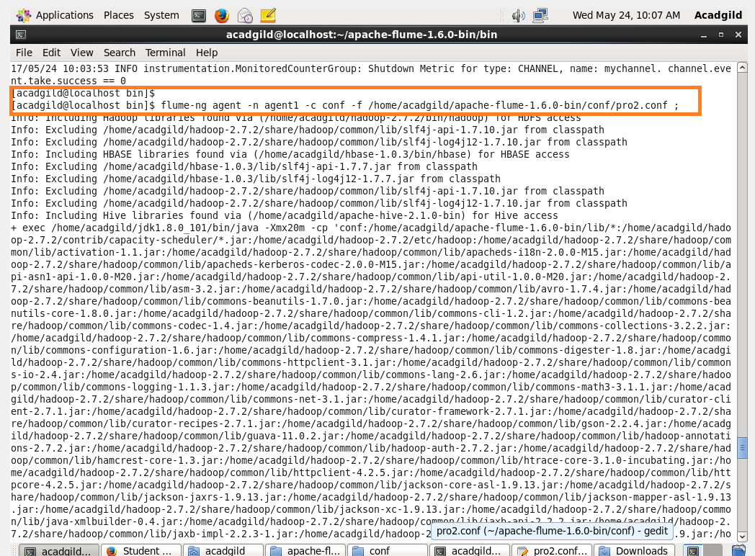

**Running the file which will have sink ,source and channel:**

* while flume is being run.



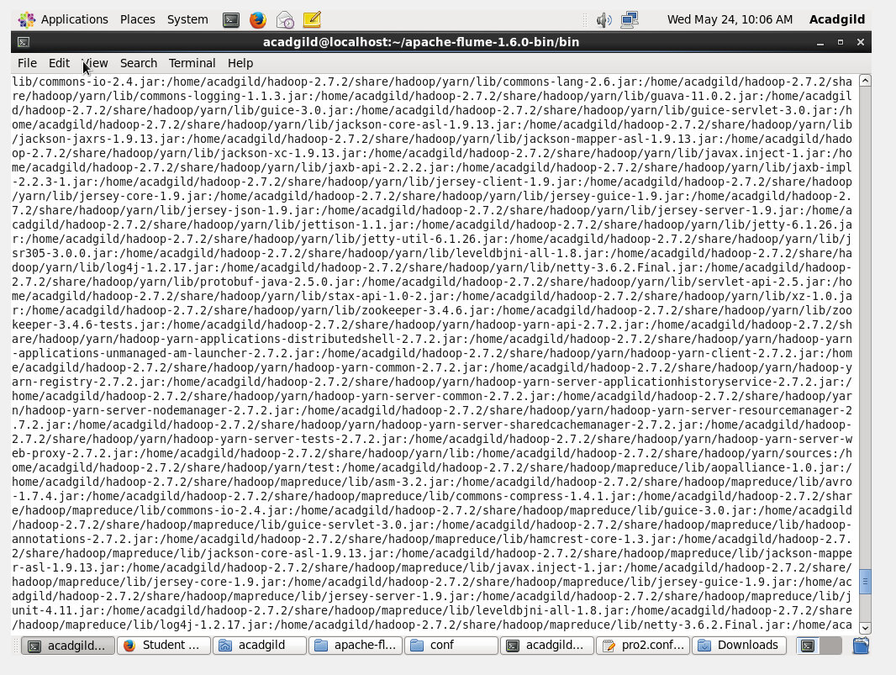

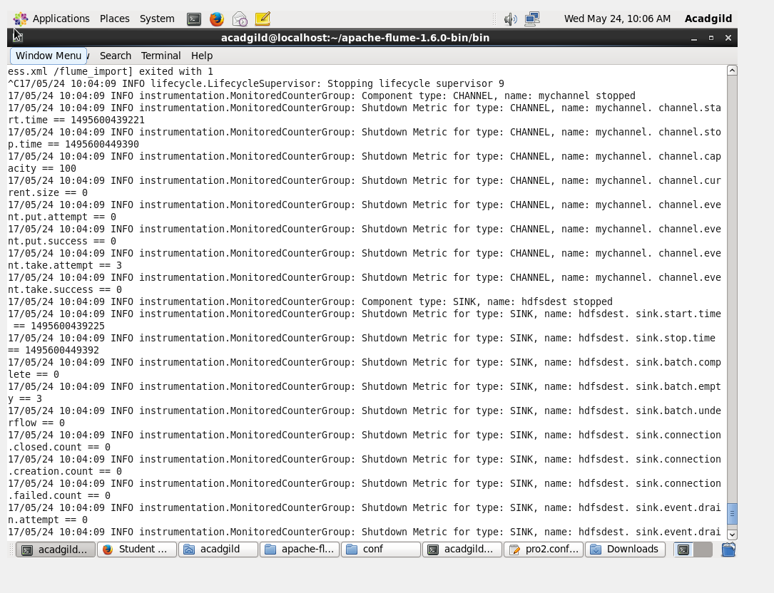

Flume command is to list all the contents inside the file flume_import

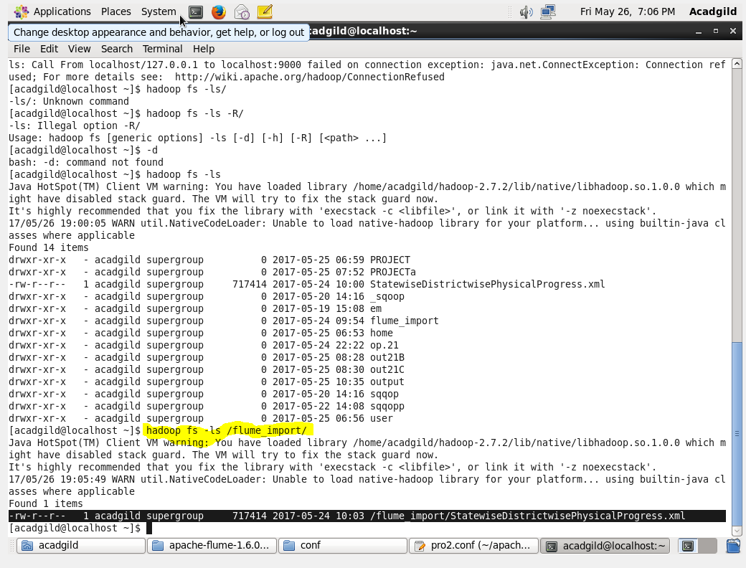

CAT command will read all the data which has been loaded.

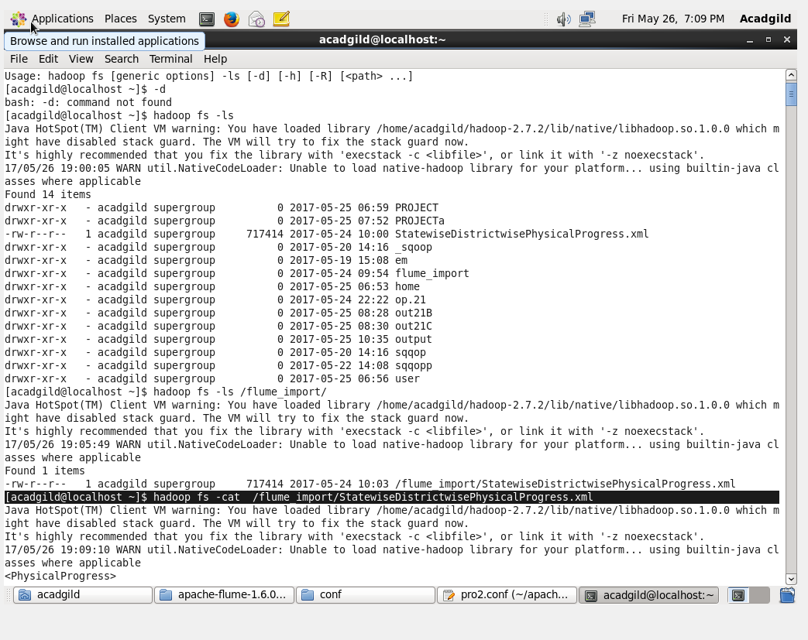

To make sure all the data were properly loaded.

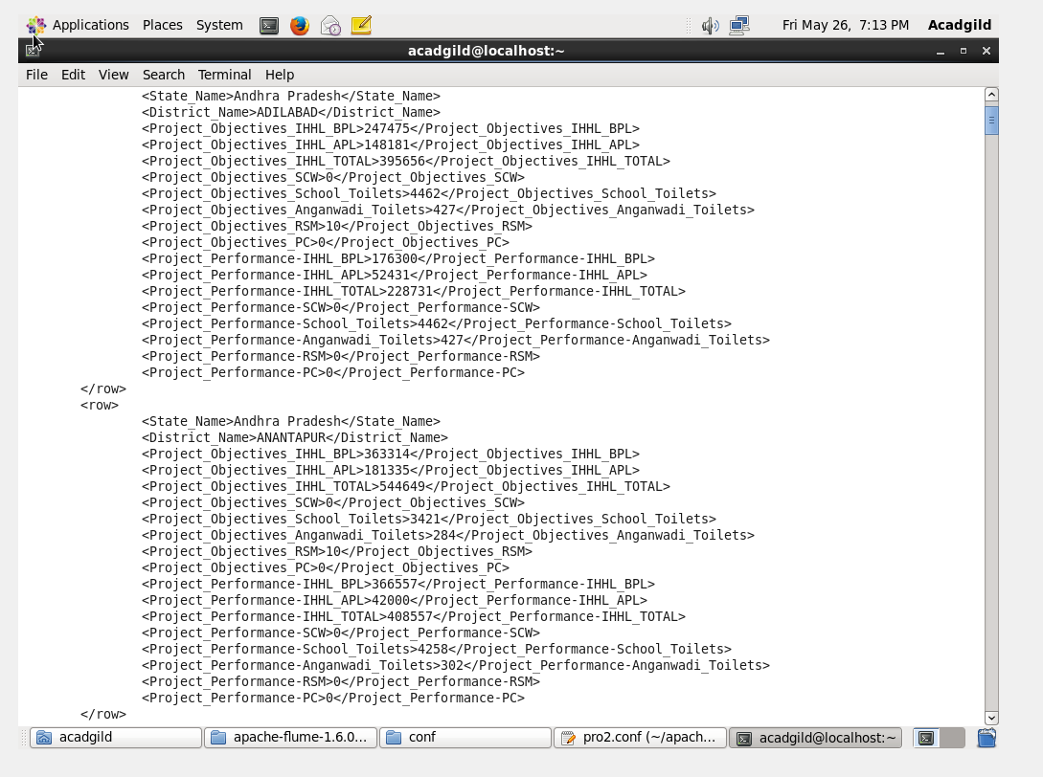

**DATA PARSING FROM XML FORMAT USING PIG:**

* **TO LOAD THE PIGGY BANK UDF TO XML BY USING XML LOADER.**
* This program has been made to run in map reduce mode.



**DATA LOADING FROM XML TO A**



***pig Script:***

* All the data inside the flume will get loaded into pig.
* **B =** HTML dataseperation format is made as ‘,’.
* **C =** All the data in the dataset were seperated by ‘,’.
* **D =** since all the data were stored in a single row flatten is in order to bring it out of bag.
* At last the dataset which has been converted will be stored inside the HDFS named as pro.

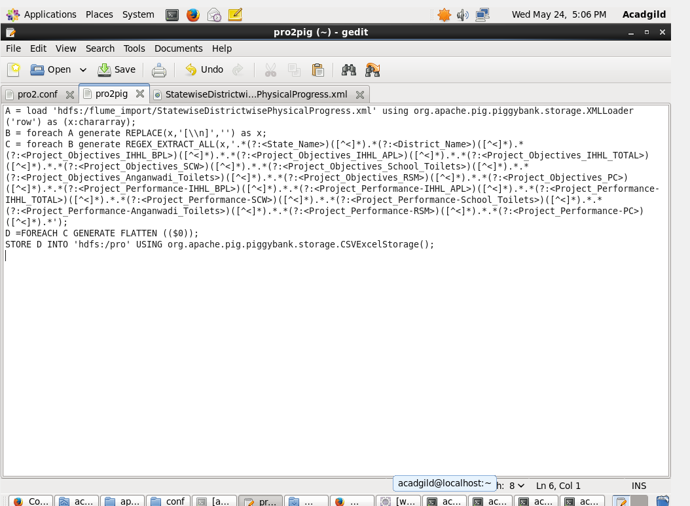

**RUNNING THE PIG SCRIPT (pro2pig) :**

* The pig script was ran by using run pigscript name( ***propig*** was use here).
* REGEX_EXTRACT_ALL command will be used in order to get the commands between tags.
* At th end will store the filewhich is flattened into the HDFS.

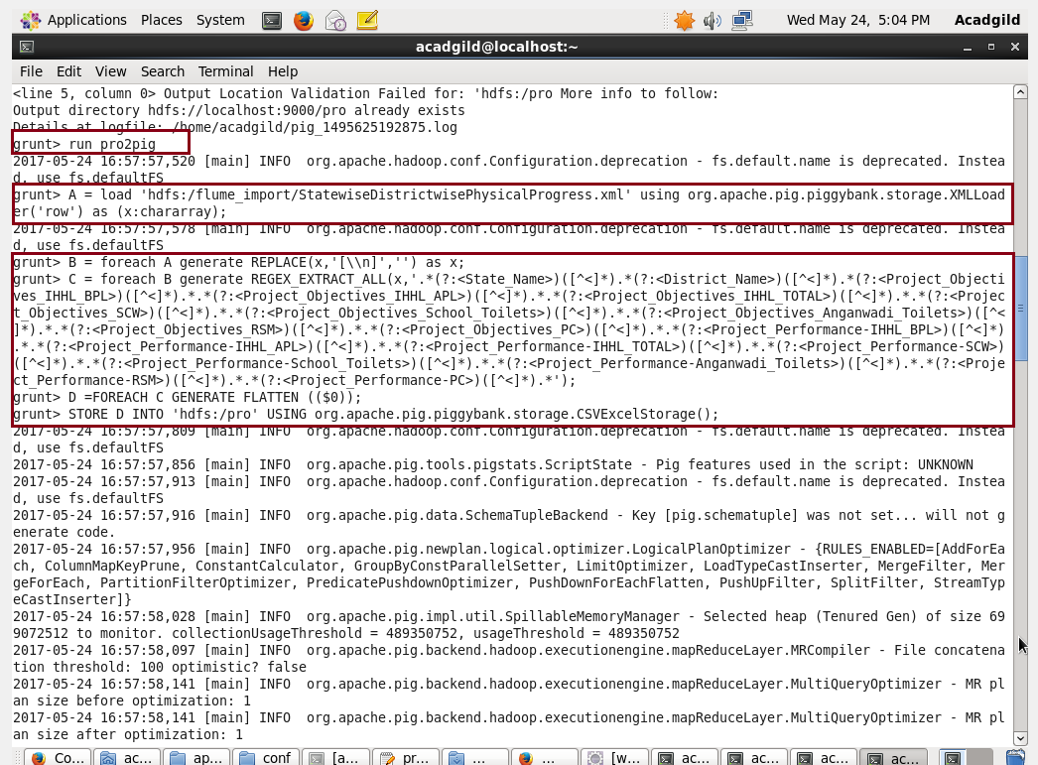

**Pig script ran successfully:**

* All the data were successfully loaded into the pig.

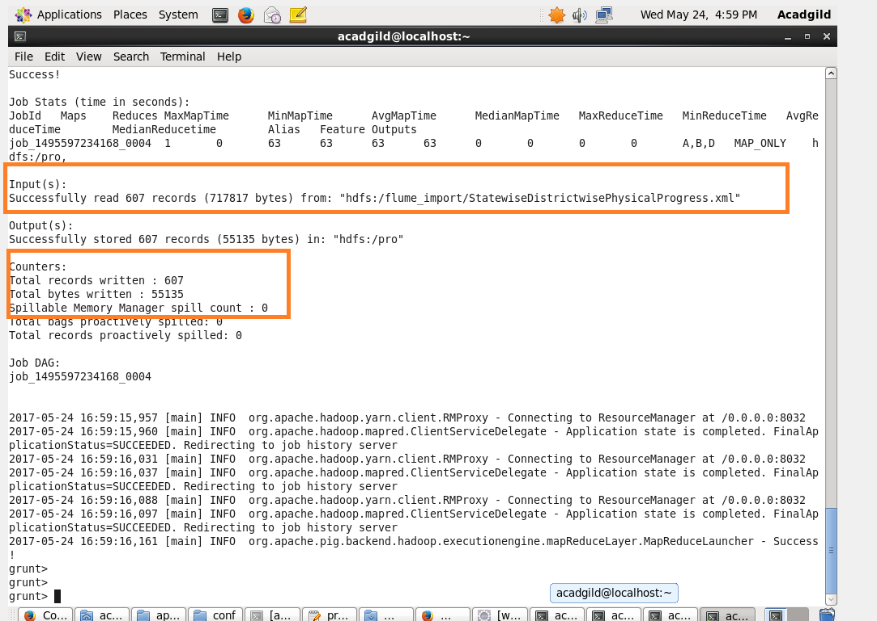

**Reading the contents using cat command:**

* By using cat command the output can be ran.

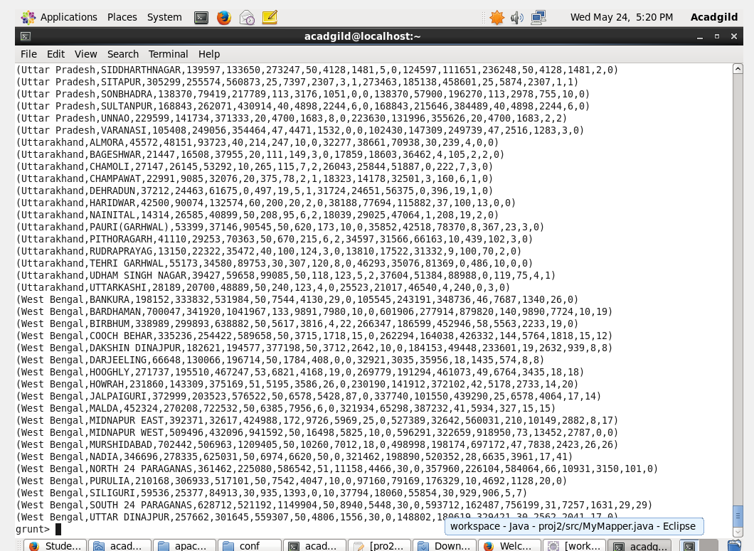

**1. Find out the districts who achieved 100 percent objective in BPL cards.**

**Export the results to mysql using sqoop.**

STEP 1:

* Loading the dataset into relation C by specifying datatype with the columns.
* Filtering the dataset by specifying condition ( performance($10) >= objective ($2) )
* As we want only district, we are generating only districts and states by specifying the column $1 and $0.
* Storing the output in hdfs by specifying the path.

**pig script:**

* **A=** Load the data from pro into pig.
* **B= F**ilter data from A where the objective of BPL($10) should be greaterthanthe performance.
* **C=**And from Bfilter only the first column (district_name).

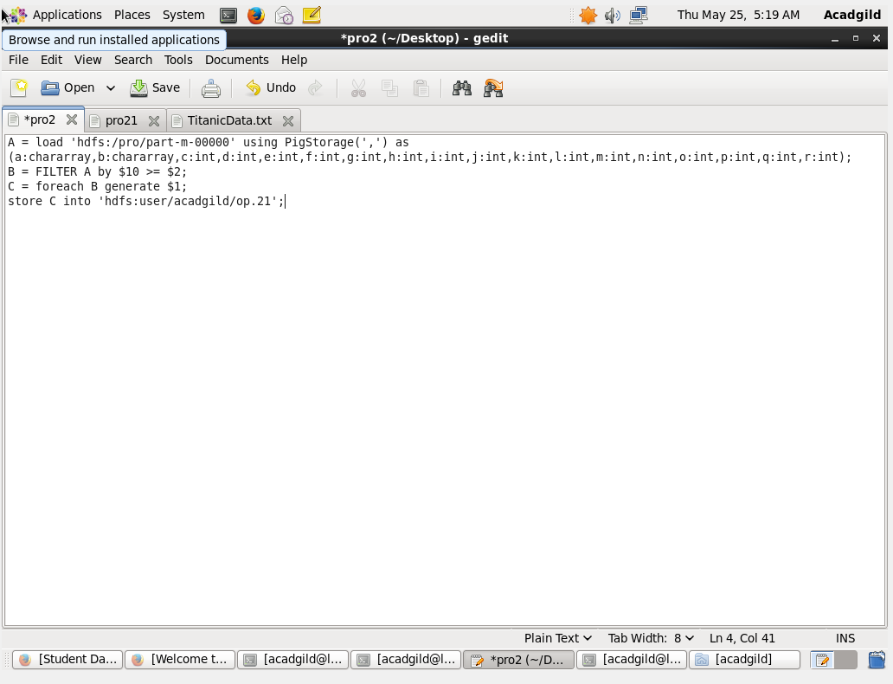



**READING THE OUTPUT USING CAT COMMAND:**

* Using cat command with the table name the output can be obtained.

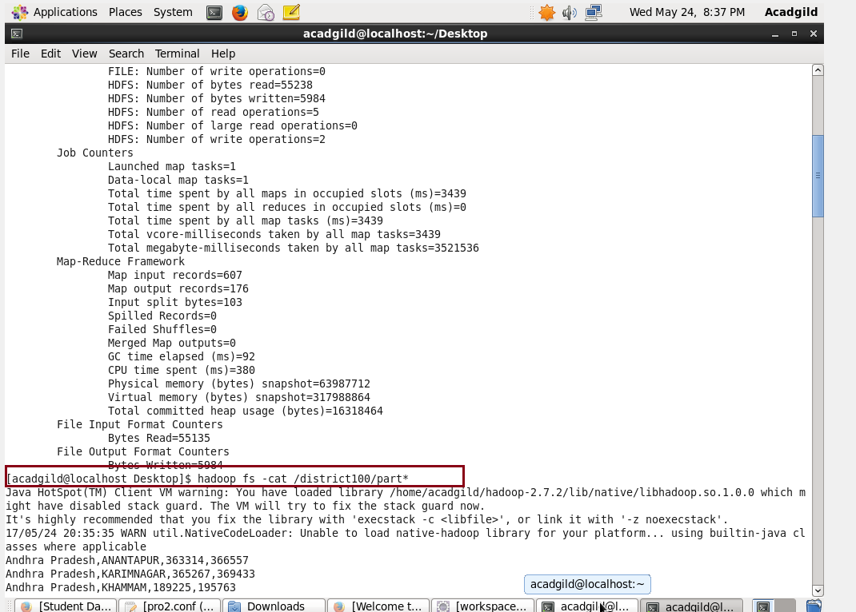

**PARSED DATASET USING CAT COMMAND:**

* Output obtained after cat command.

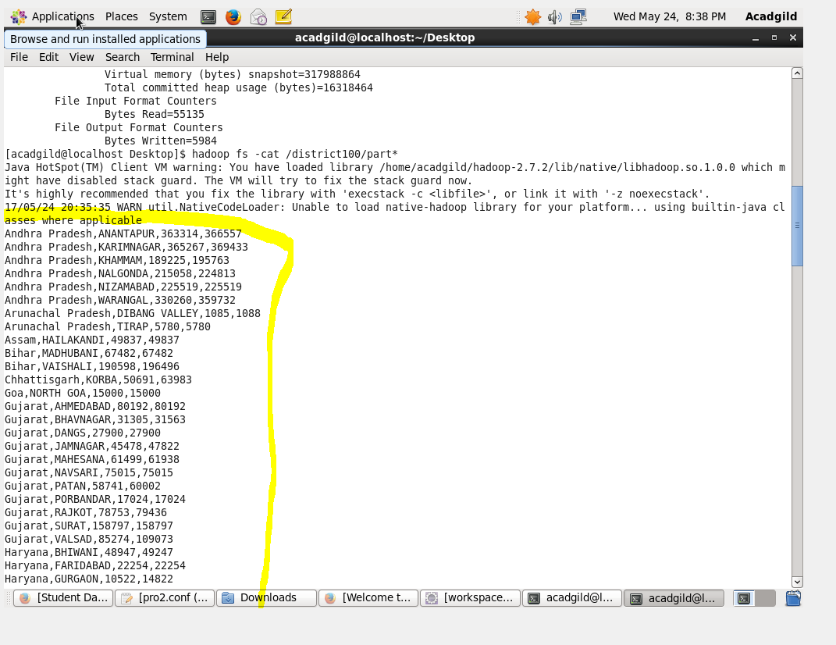

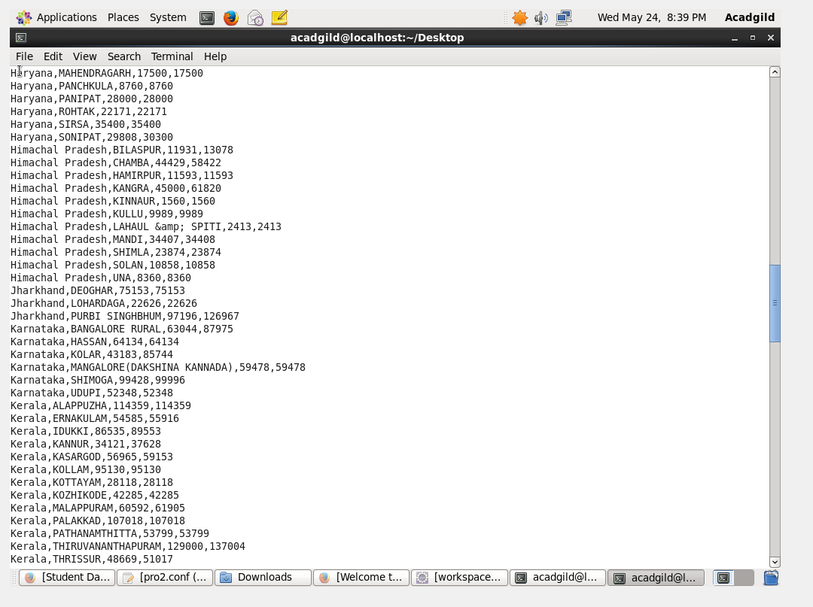

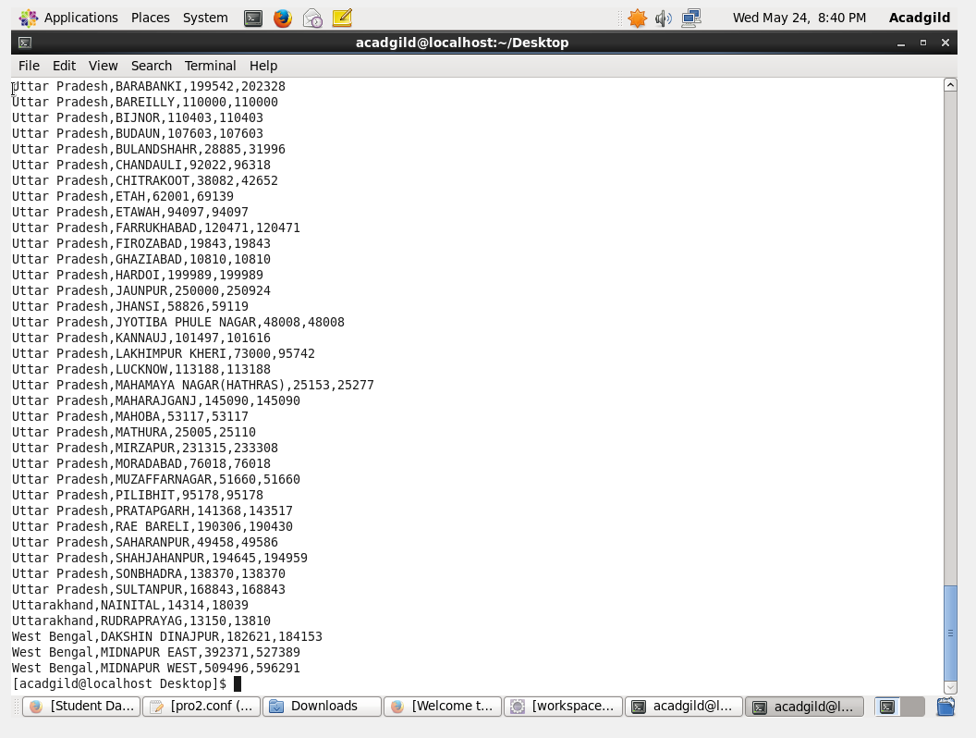

**TO EXPORT THE RESULT FROM PIG USING SQOOP:**

1:choose a database.

2.Then create a table and check whether the table is empty. In order to export the data to that table.

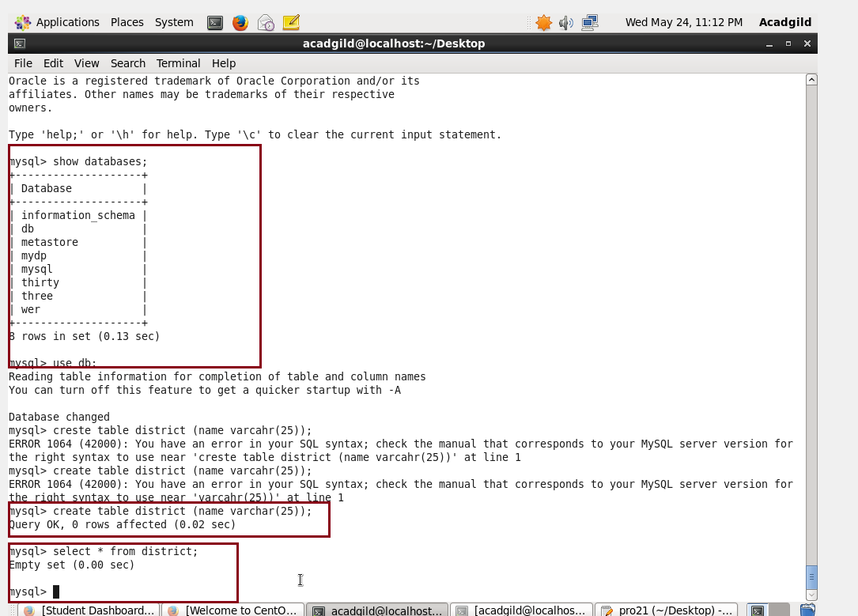

**Load all the data into the table:**

* By using sqoop all the data will be exported into the empty table.
* The directory of the table should be perfectly method which includes the table name.

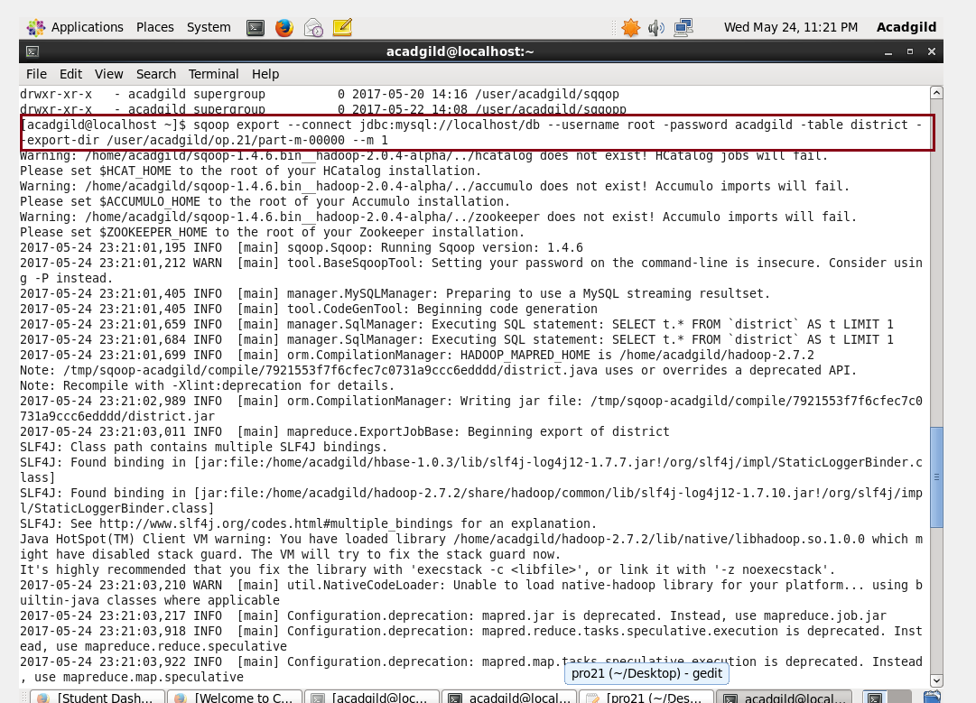

**Data getting loaded:**

* All the data were successfully loaded.

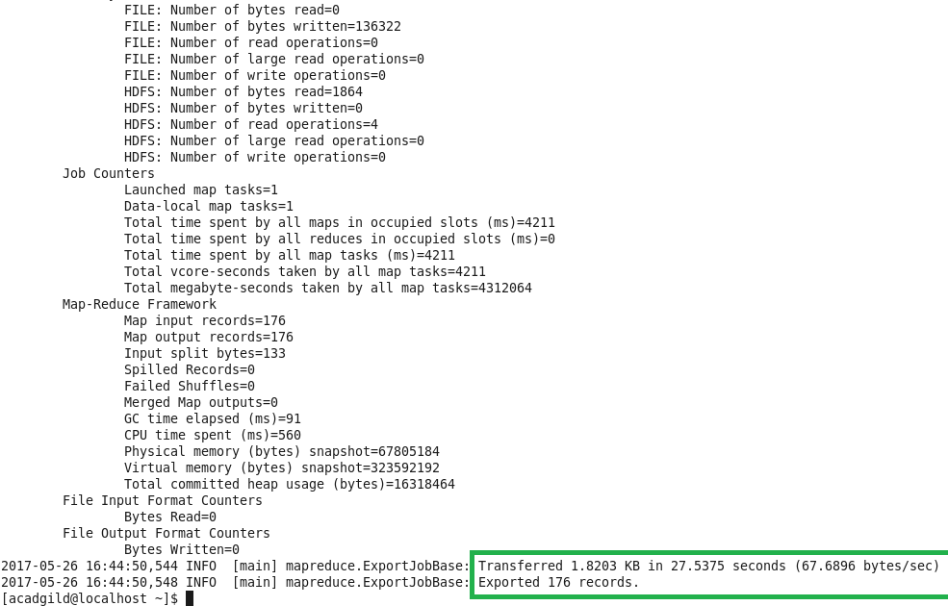

**Output:**

* Once the data got loaded. It can be checked by selecting all the from the table.
* Since the data is loaded all will be listed.
* At the begging the table is empty.
* After the data gets loaded when all is selected from the table it will list the data present inside.

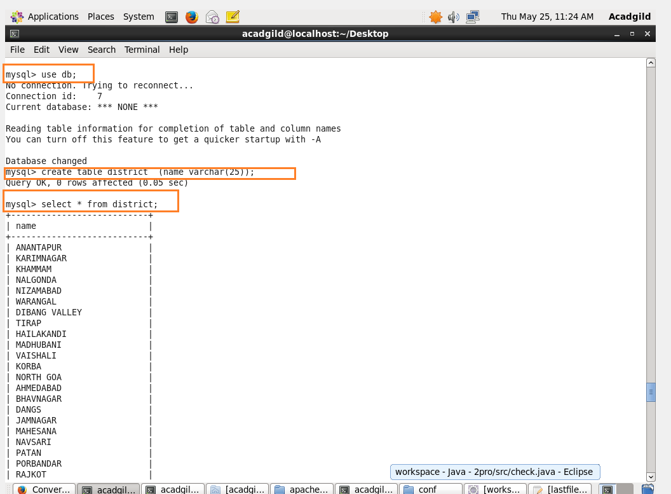

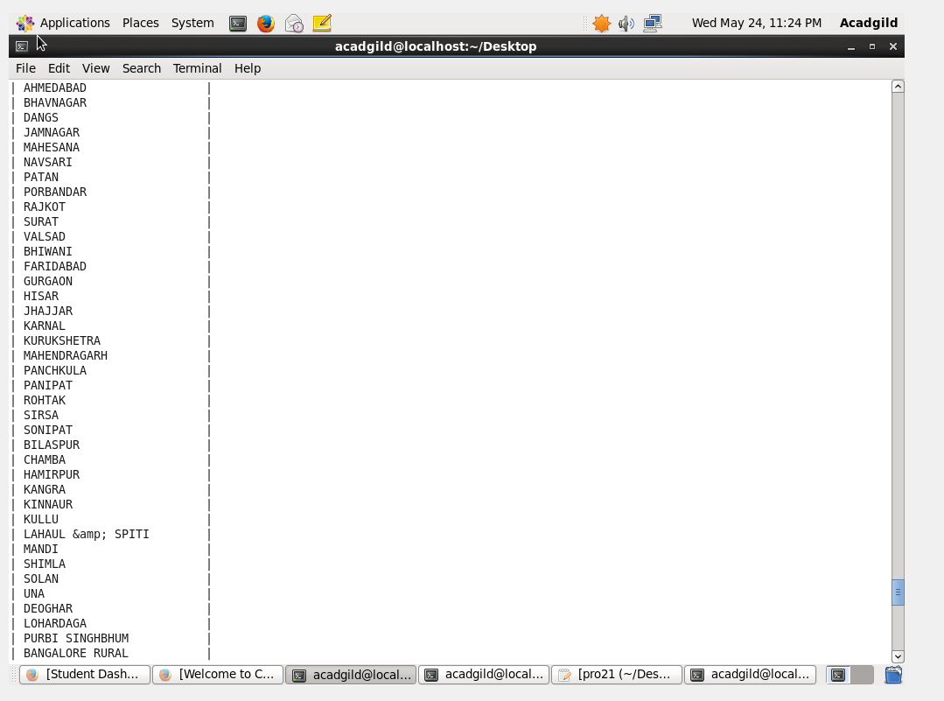

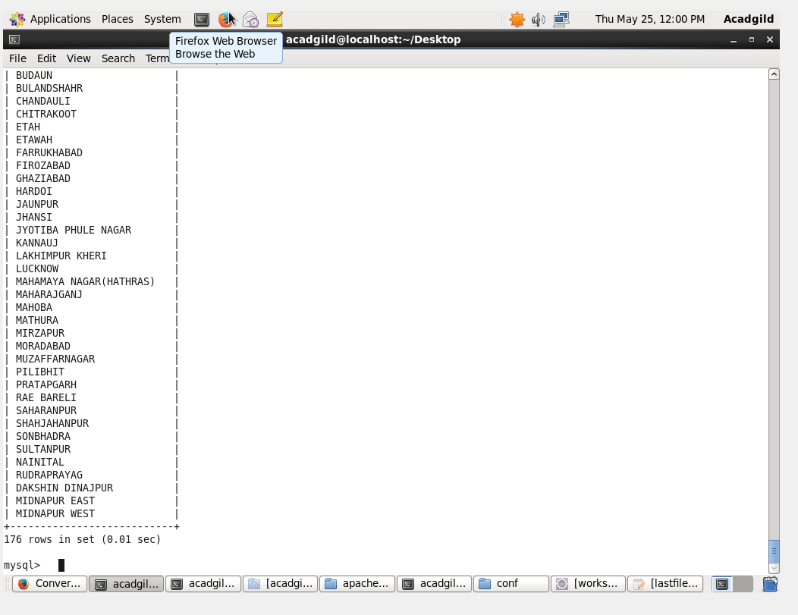

**Write a Pig UDF to filter the districts which have reached 80% of objectives of BPL cards. Export the results to MySQL using Sqoop.**

*WRITING USER DEFINED FUNCTION TO FILTER THE DATASET.*

*FILTERING THE DATASET BY SPECIFYING CONDITION ( PERFORMANCE >= 0.8 * OBJECTIVE )*

**UDF :**

* When the input is null / empty by any means it will return null.
* The input is made as String and later it will be made as int again.
* First int will be made as String and again it will be made as int.
* When the (a >= (b*(0.8)) –this means to achieve 80% target.
* Then it will return true else false.

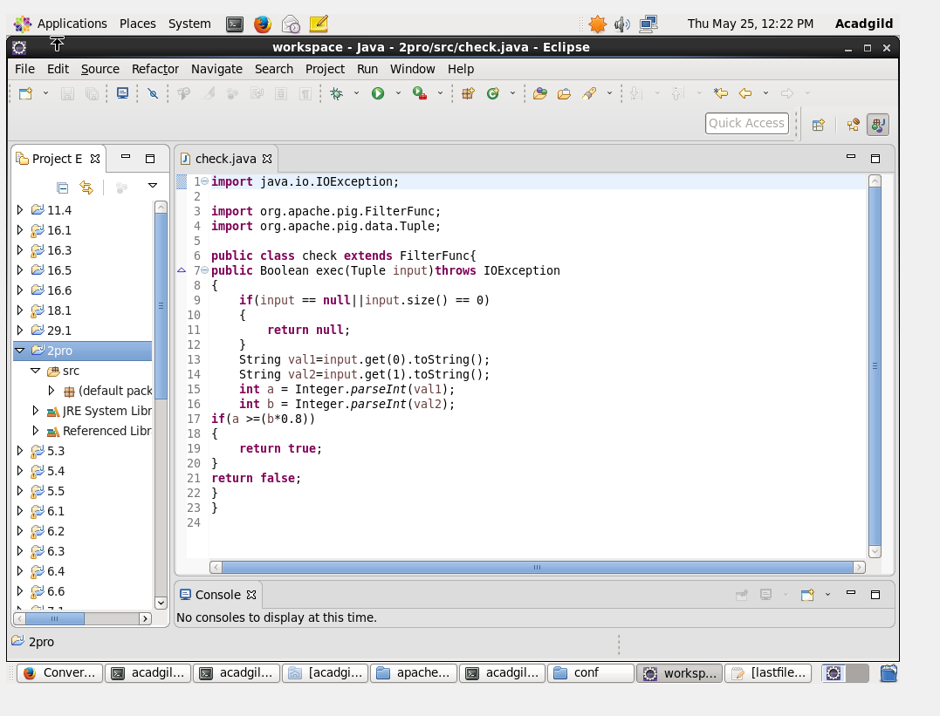

**PIG SCRIPT:**

* The pig script was named as ***mjrpig2.***
* The jar file was registered .
* **P=** all the data were loaded inside.

**A=** data inside P were filtered $10 is the project objective in BPL cards column

$2 is the project performance in BPL column.

* Then only districts were filtered from the second column.
* All the data which were filtered will be stored into D.

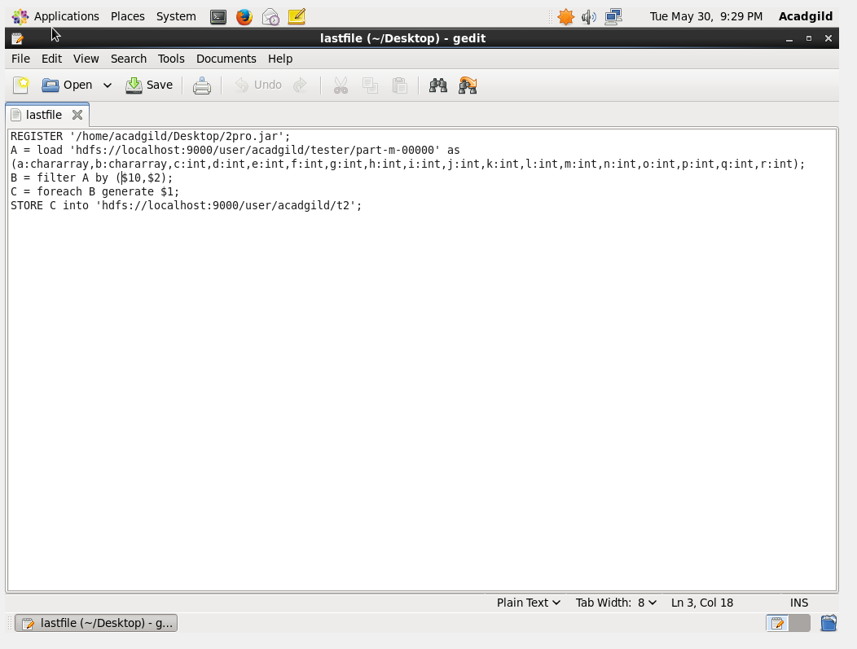

**TO RUN THE PIG SCRIPT:**

* The pig script was run in hadoop.
* Pig command followed by the script name will run the script.

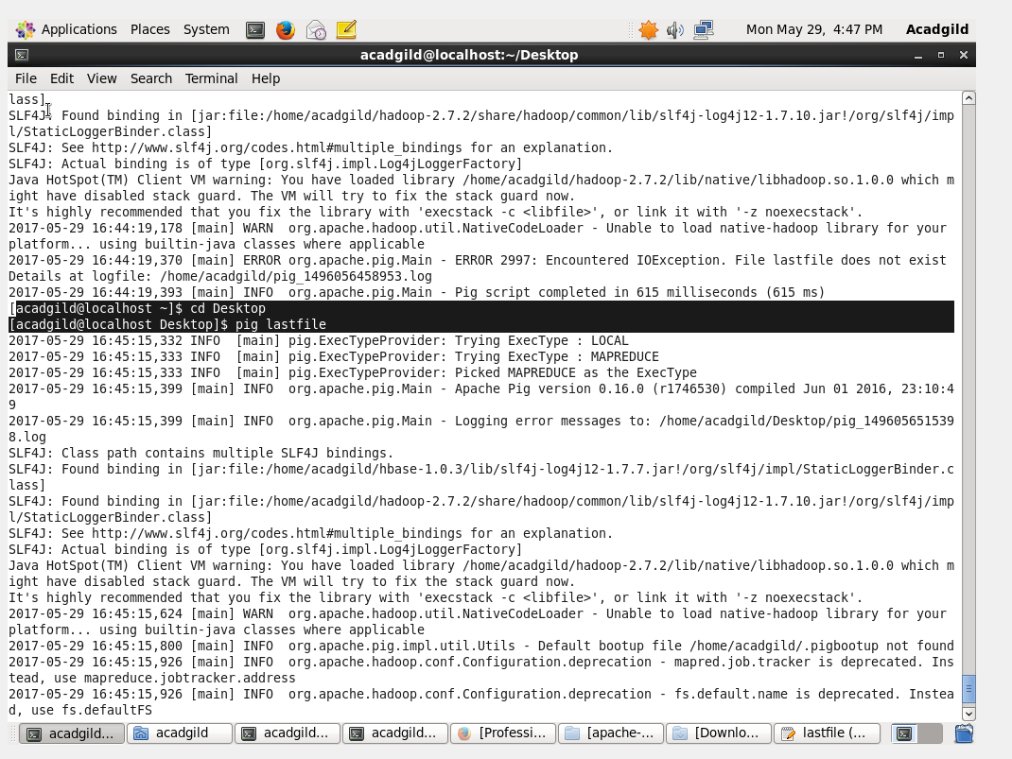

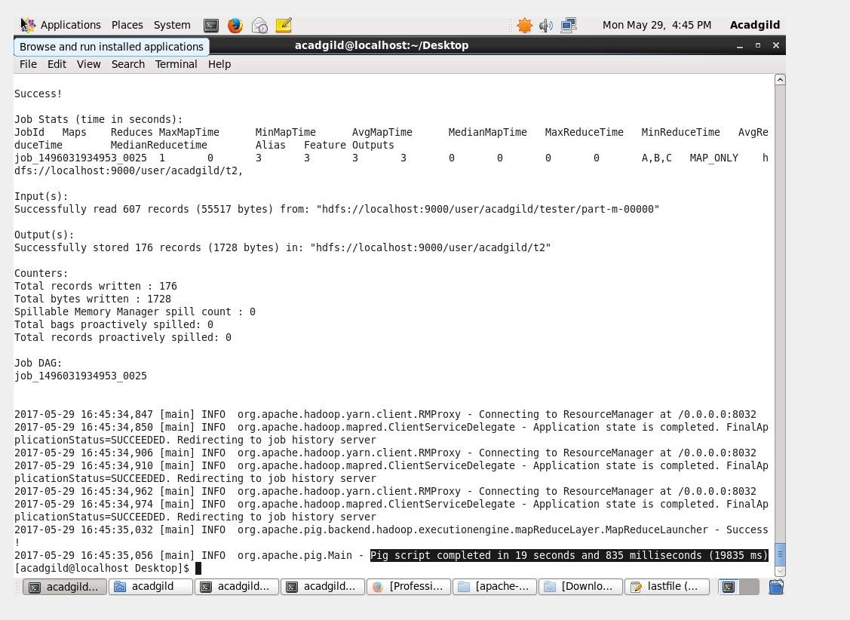

All the records were successfully exported.

**Listing the file:**

* By listing the file we can see the contents of the file.
* This is make sure whether the file is loaded.

**CAT COMMAND:**

* Cat command is done in order to read the dataset which has been filtered.

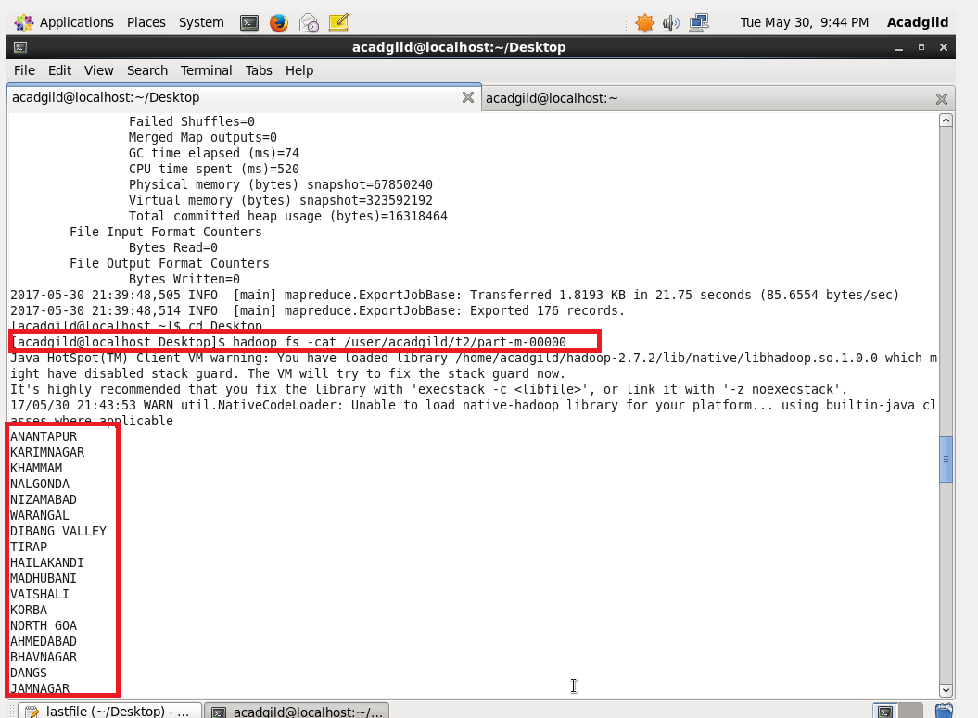

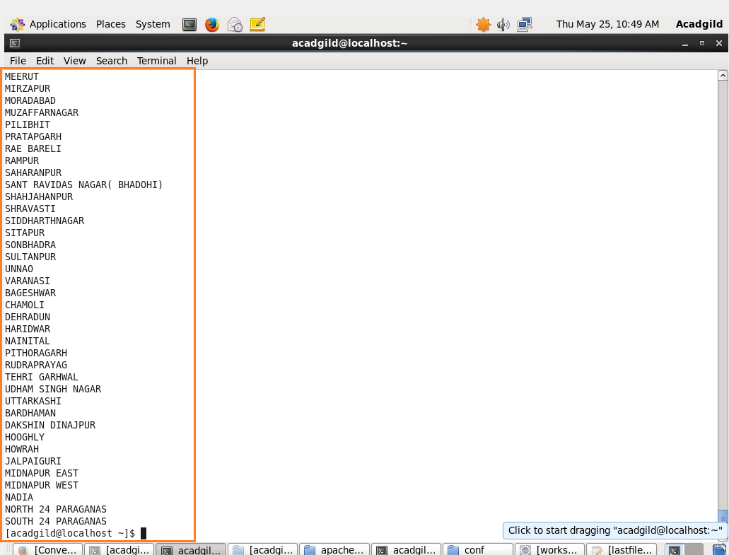

* A database need to selected first.
* Inside the database create a tablenamed:***disc***
* Select all from disc to make sure that it is empty.

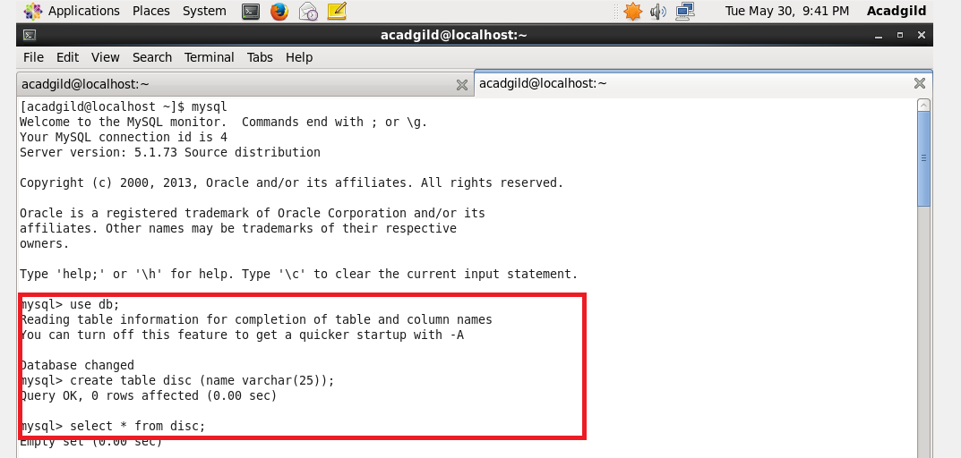

**EXPORT USING SQOOP**

* Below is the export command to perform export operation.
* By using sqoop command all the contents can be exported from HDFS to SQL.
* And the data can be checked in sql by selecting all again from the table.

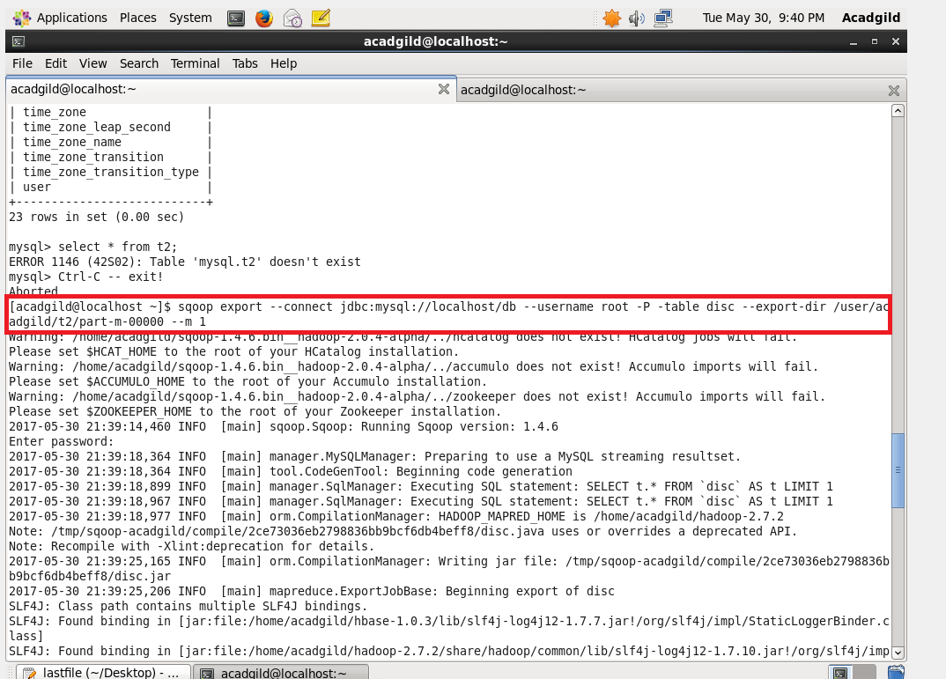

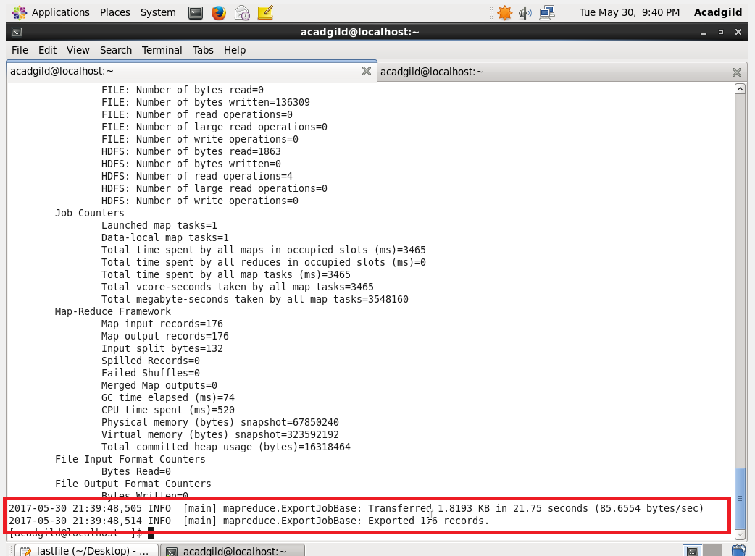

**OUTPUT IN SQL:**

* Again by selecting all from DISTRICT2 table we can find the results.

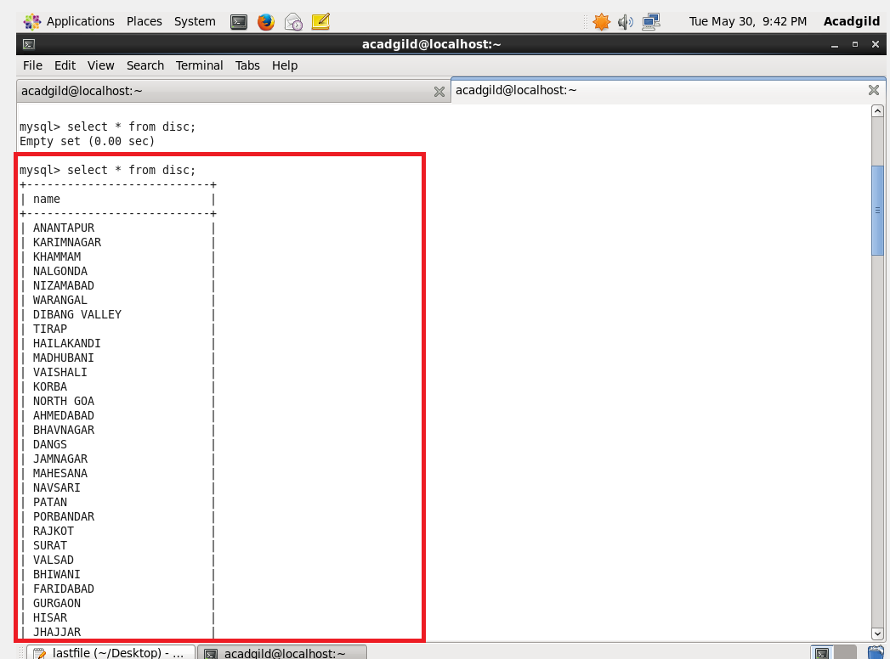

All the output were attached in a separate file.